**Capstone Project – Azure**

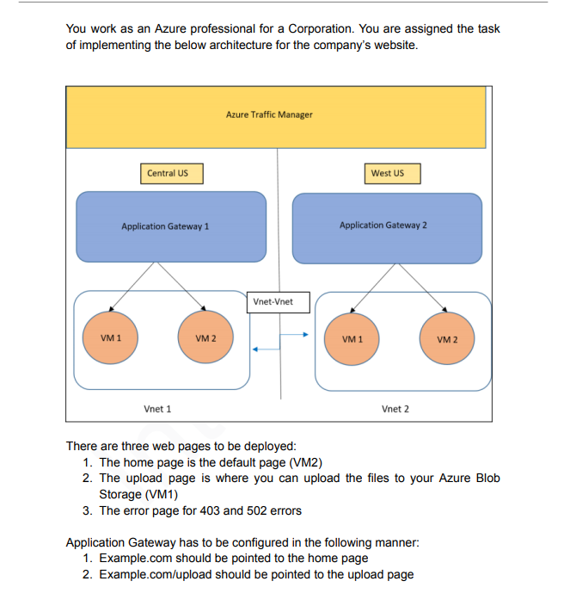

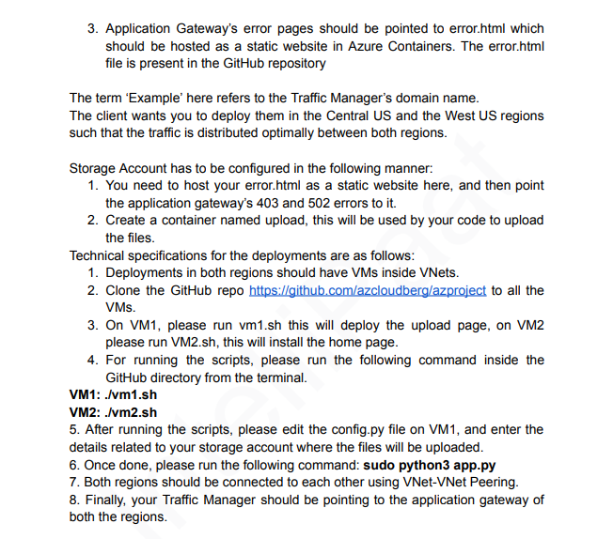

1. Create 2 Virtual Network. 1 in Central US and another in West US.
   1. Central US

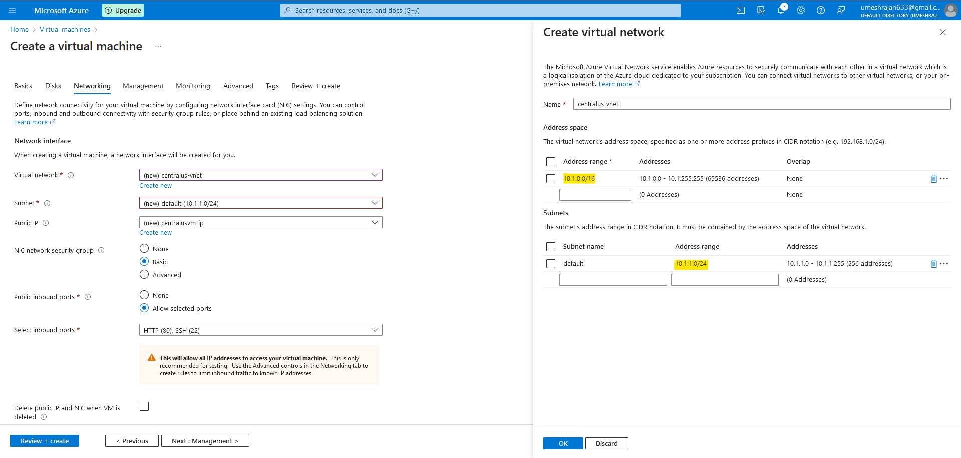

* 1. West US

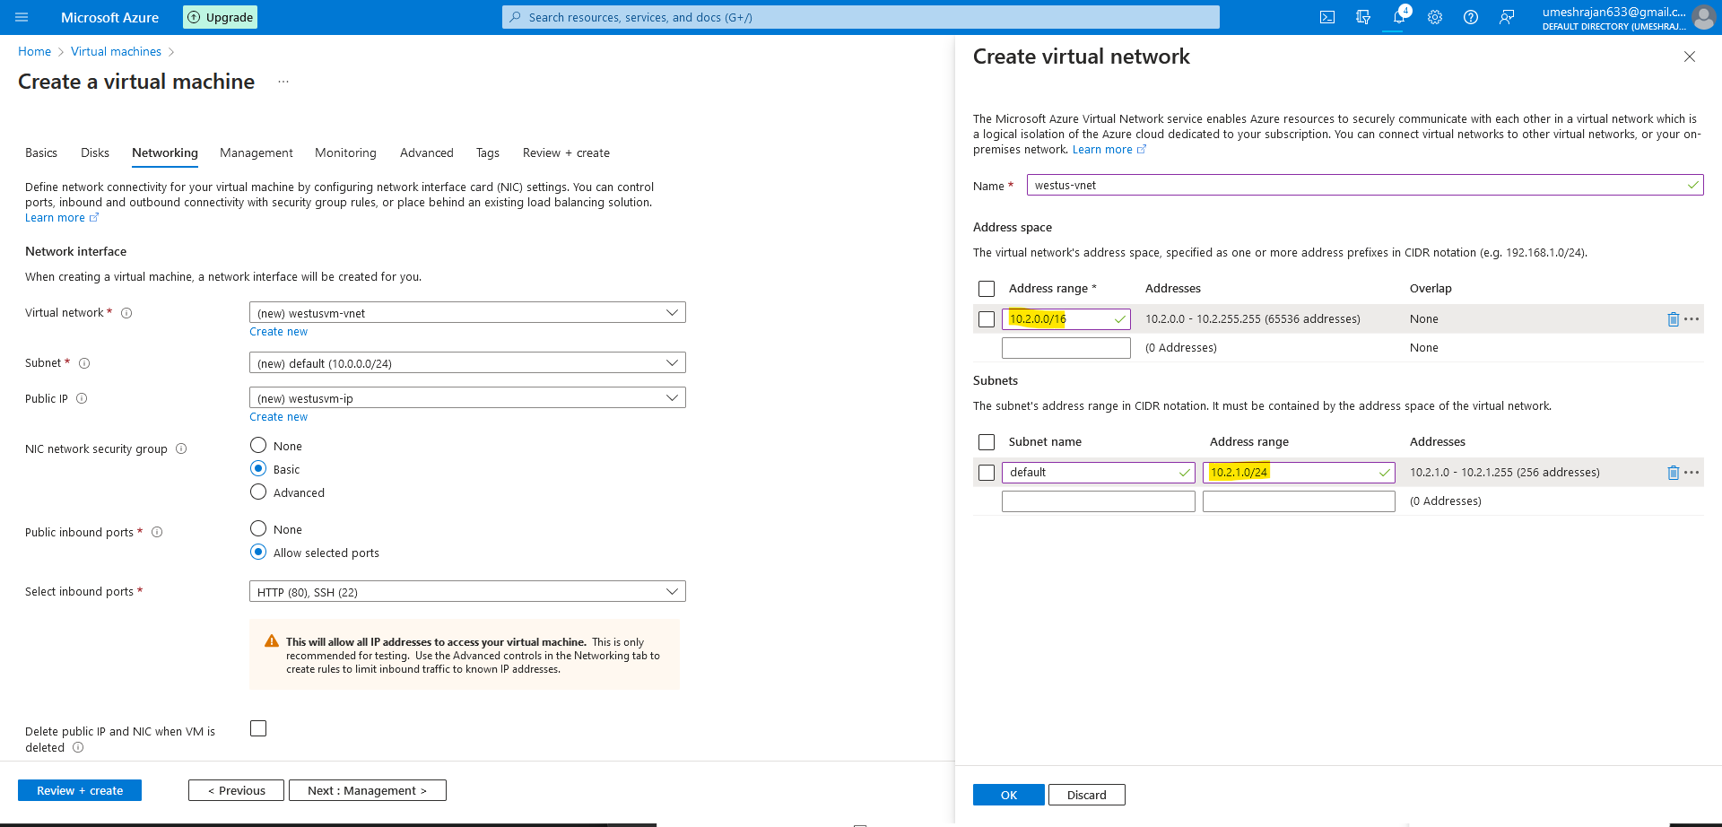

1. Create 2 VM’s across 2 region. VM1 and VM2.

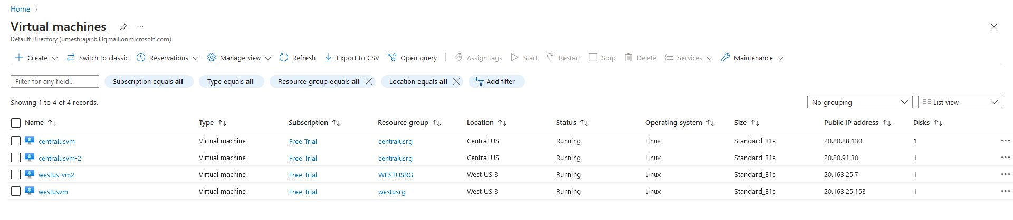

1. Clone the git repo on all the VM and run the Script on vm1 and vm2 accordingly.

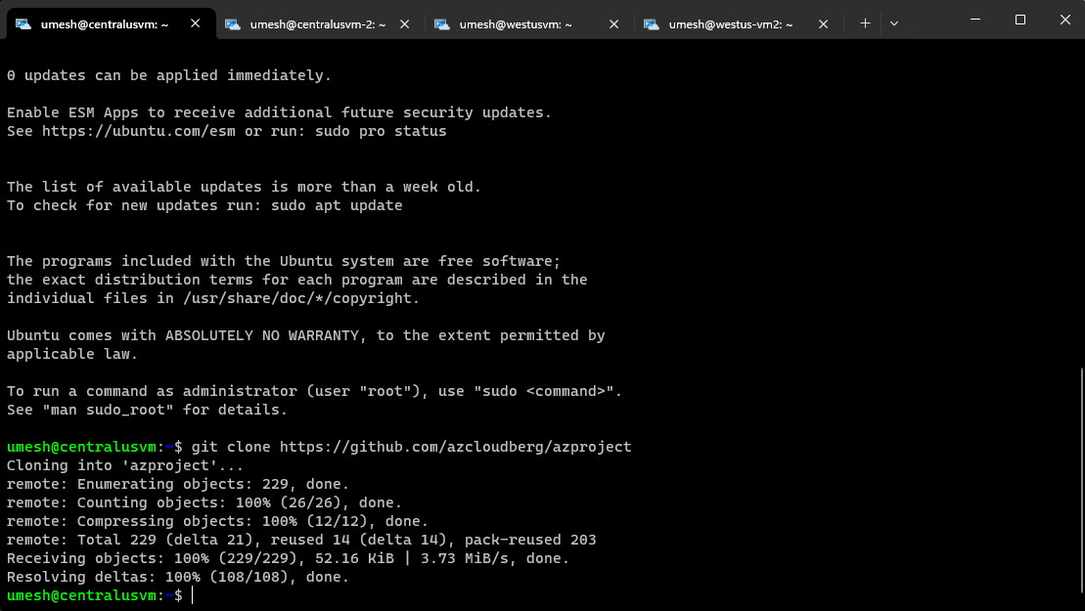

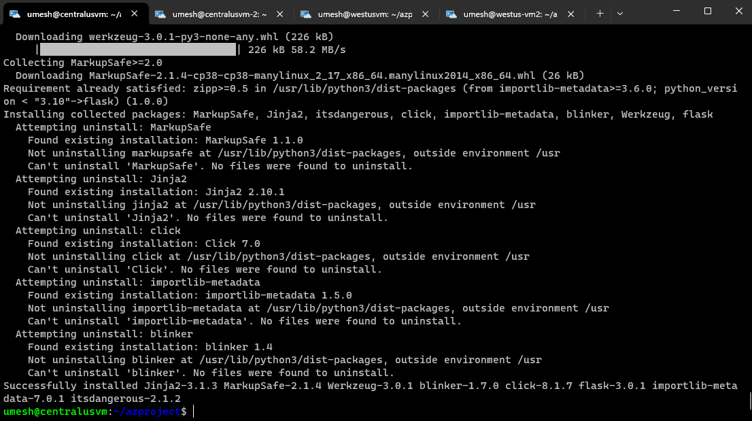

1. Add Virtual Network Peering.

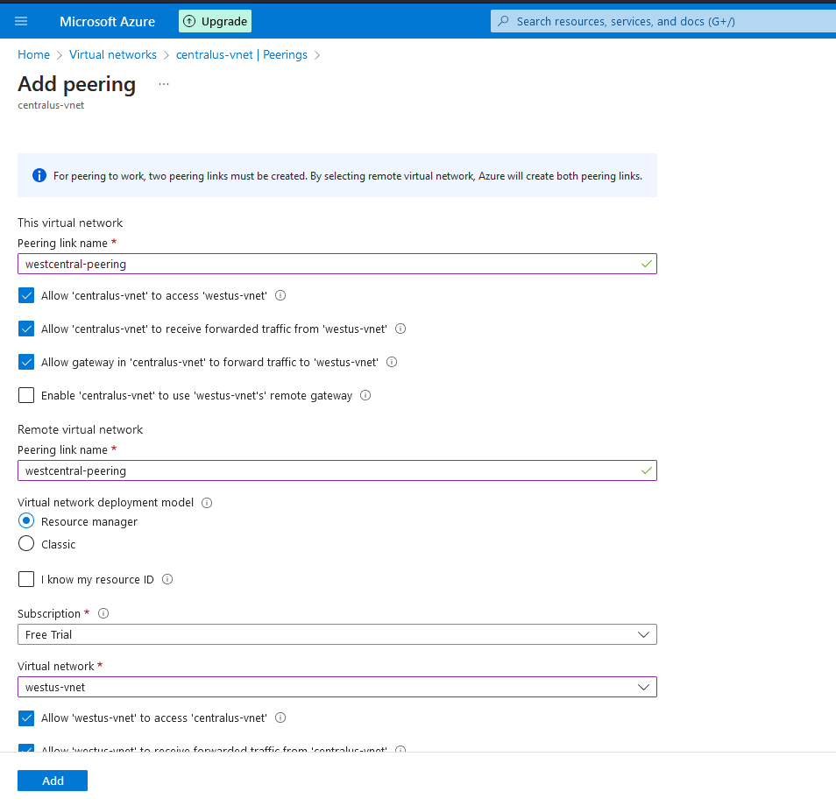

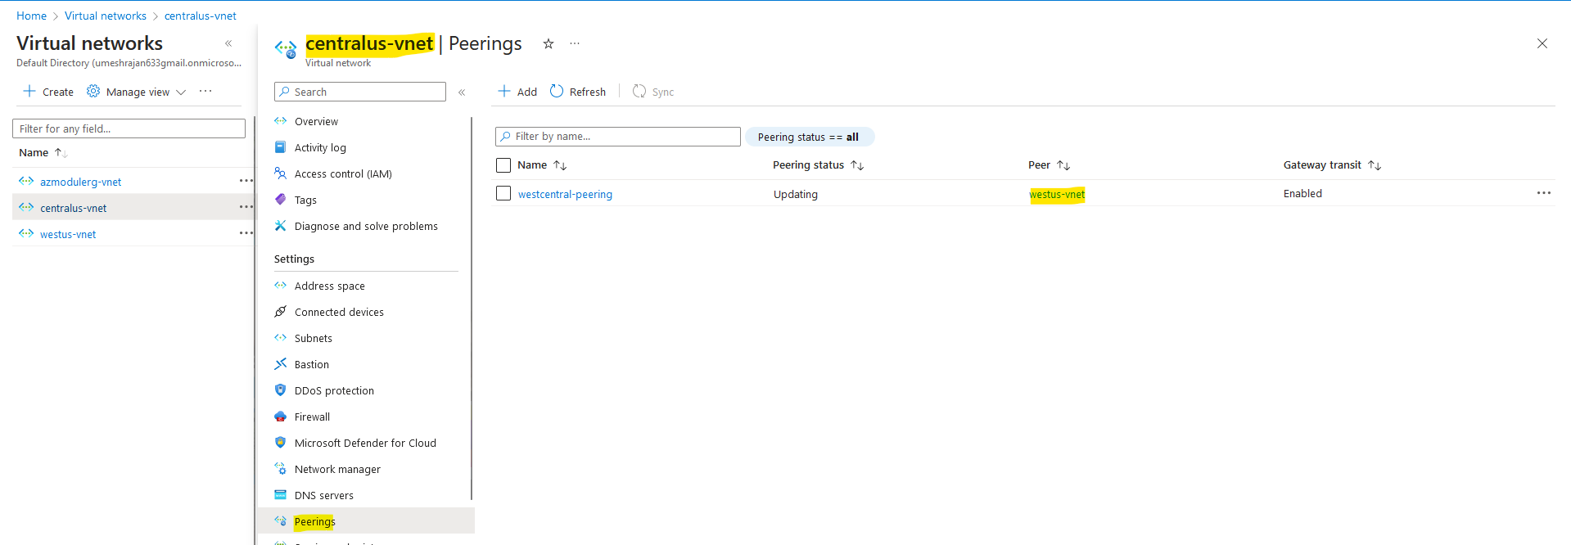

1. Create 2 Storage Account, one in each region to upload the error.html file. Create a container named upload.

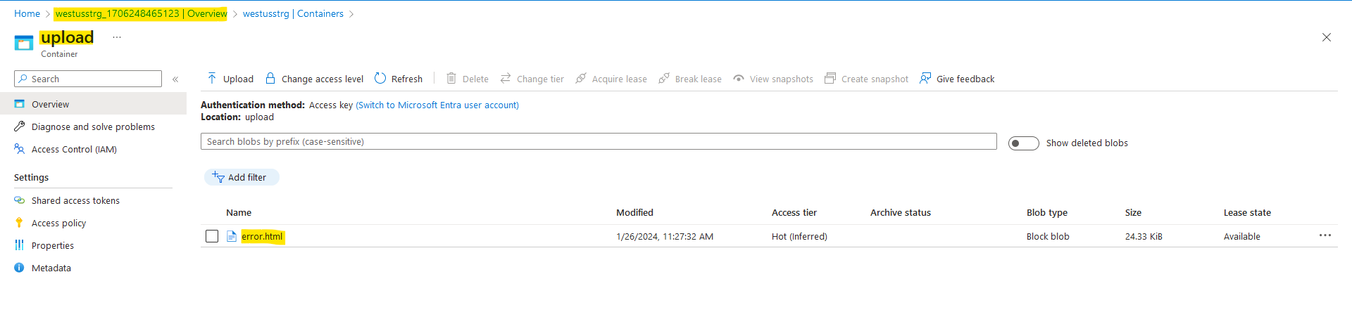

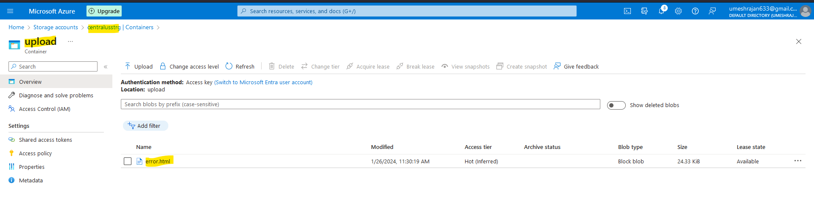

1. Configure Application Gateway for both the regions.

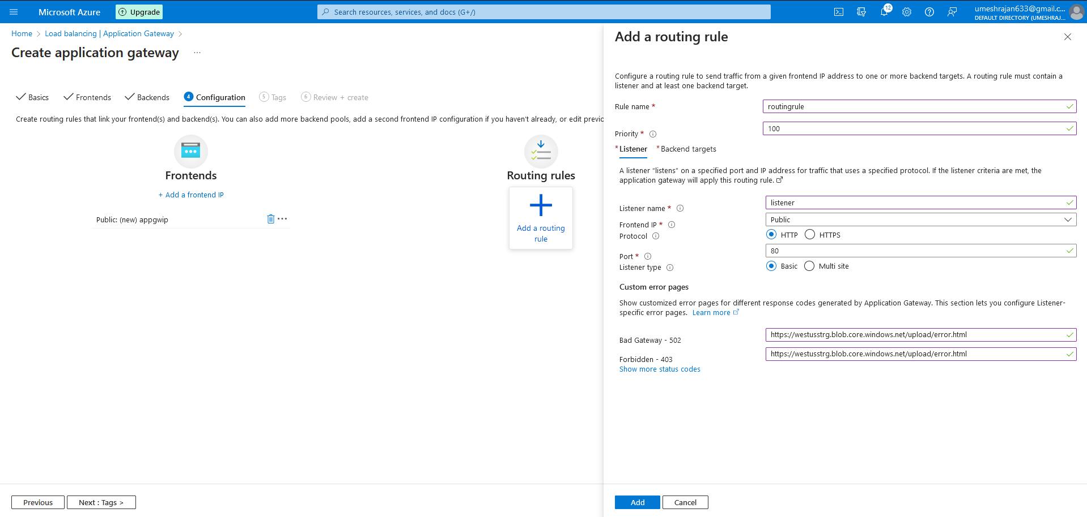

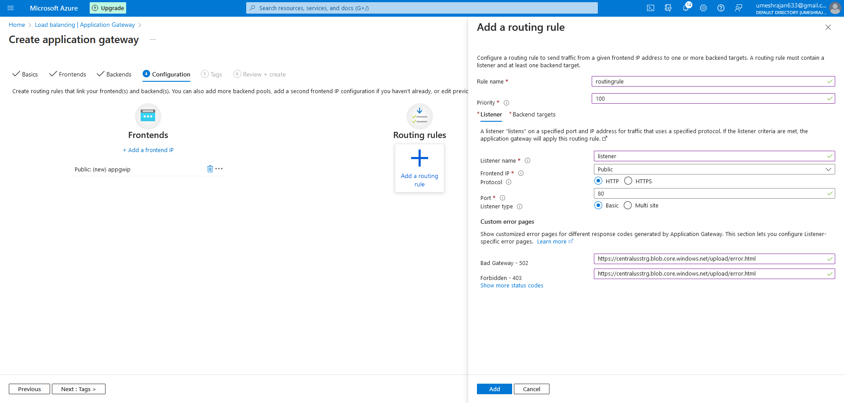

1. Create a Traffic Manager Endpoint and provide both the Application Gateway into the Traffic Manager. Assign DNS Name to both the Public IP of the Application Gateway and add the Endpoint.

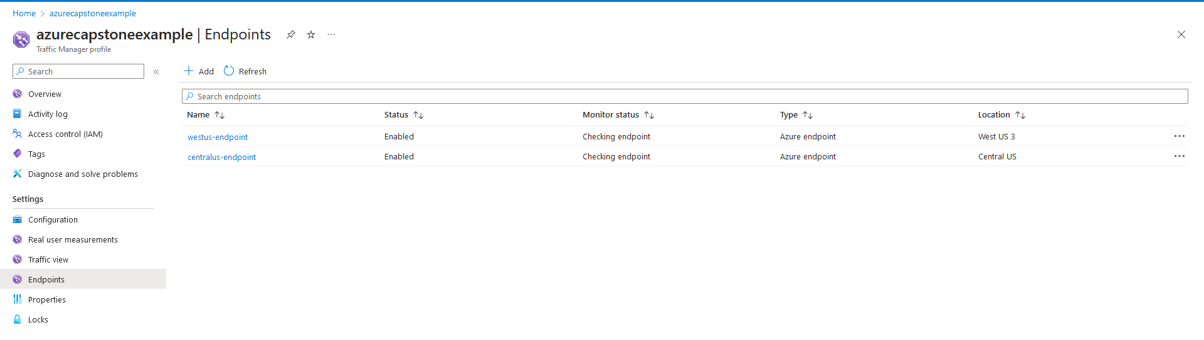

1. Configure Path-Based routing in Traffic Manager.
   1. <http://azurecapstoneexample.trafficmanager.net> – should point to VM2.
   2. <http://azurecapstoneexample.trafficmanager.net/upload> - should point to VM1.
2. On each VM1, edit the config.py with the storage account for each region.

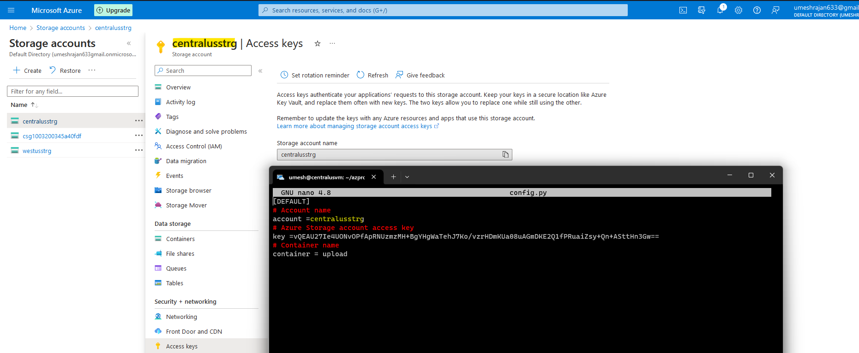

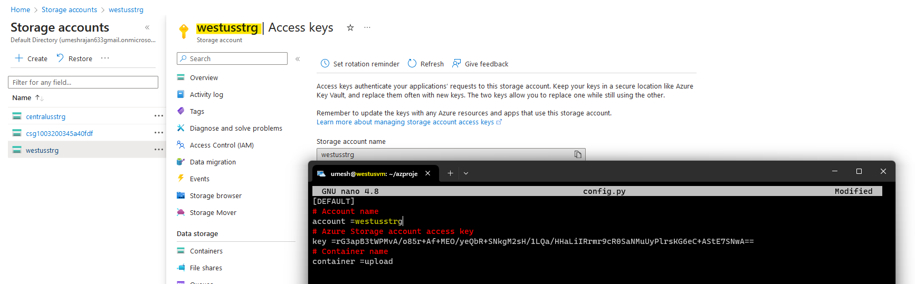

1. Run the app on both the VM : sudo python3 app.py
2. Now access the traffic manager on both : base url and /upload

